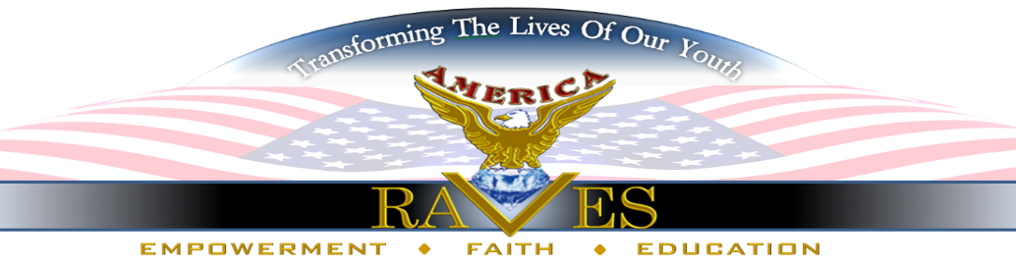
Dear Sponsor/ Supporter:

“IT’S UP 2U” ©Youth Project- How Can I Sponsor Summary:
America RAVES is a registered 501 (c)(3) non-profit that has a 20 -year track record of advocacy and empowerment services geared towards young people ages 10-25 years old because we believe that offering alternatives to negative and distractive forces allows young people to thrive and reach their highest possibilities as future leaders. By Implementing programs and projects that challenge them educationally, socially, and financially, young people are able to choose courses of action that contributes to positive decisions regardless of issues that may impact their daily lives.
Project- Statistics show 1.1 million parents are in federal, state and local facilities. These parents have an estimated 2.3 children with 90% being fathers. This disruption in the family dynamic causes many changes such as living arrangements, depression, poorer peer relations, anxiety, withdrawal, eating disorders, shame and guilt for the children. The project is designed specifically for the social and emotional support of youth 8-18 years old who have a parent incarcerated because it has been discovered that this age group is greatly affected by the incarceration of a parent, especially coping with separation. disconnect and inability to see parent daily. This unique social justice initiative offers prevention and coping skills allowing youth to thrive in the midst of this life altering experience.
“It’s Up 2U” is a three-phase project to promote the mental, social and spiritual health of the youth. However, your sponsorship is requested to support the Sneaker Ball Theme. It is an elegant evening of fun, fine dining, and lots of hugs. 50 youth will attend, along with Guardian and Volunteers from the community. Our goal is to reach youth from a positive emotional and spiritual perspective, to boost esteem, instill pride and advance their personal self-worth. Your help is needed in this huge effort to ensure youth have an amazing experience. Please see list of items below for Sponsorships. Budget will ensure youth have attire, grooming and sneakers. Other considerations include venue cost, catering, speakers, Swag bags, publicity and decorations. You may sponsor a youth @ $50 per person to attend the ball.
Date, June 23, 2023, 6:00 PM- H.J. Russell Innovation Center, 504 Fair St SW, Atlanta, Georgia 30313.
Event Tickets: $50 per person. You may Sponsor ALL 50 Youth @ $2,500.
Diamond Level- $25,000 to sponsor entire event. You will receive back cover of Souvenir Journal, Branding, inclusive of Logo presence, Social Media presence, Plaque, Special Recognition, exposure on big screen and table (6) Complimentary tickets.
Platinum Level -$5,000-Over- You receive Branding, inclusive of Logo presence, Social Media presence, Plaque, Full page in Souvenir Journal, exposure on big screen at event and (4) Complimentary tickets.
Gold Level- $1,000-$4,999- You receive Branding, inclusive of Logo presence, Social Media presence, Certificate of Appreciation, Half Page in Souvenir Journal, exposure on big screen at event and (4) Complimentary tickets to event.
Silver Level-$500-$999- You receive Social Media presence, “Thank You” Letter, mention in Souvenir Journal and (2) Complimentary tickets to event.
All donations, contributions and sponsorships are tax deductible. Enclosed is information and ways to donate. You may contact us at: americaraves@gmail.com or call 404-861-4908. To contribute online, please click on www.americaraves.org or CASH App-$overandabove. Please visit www.Facebook.com/americaraves for activities and updates.
We can’t wait to speak with you regarding your participation.
Thank you for allowing us to share this amazing social awareness event with your company.
Sincerely,
Beverly Rhodes, CEO

“Our youth are not leaders of tomorrow. They are leaders of today”

