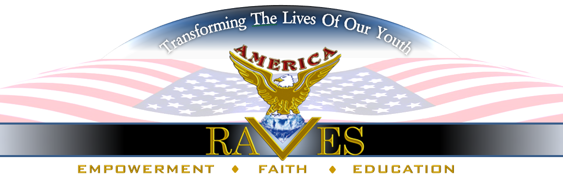

314 Laurel Ave SW, Atlanta, Georgia 30310 404-861-4908

Dear Sponsor/Supporter:
This year will be exciting for America RAVES, filled with many inspiring projects and programs to Empower, Educate and Enhance young people.
In 2018, we will continue with our Initiatives in HIV Awareness and Domestic Violence with a wide-range of activities and educational platforms to engage as many young people as we can reach.
Some of our projects this year will allow us to broaden our horizon as we expand outside of Atlanta Georgia into other regional areas for life-impacting events for our generation of millennials.
Just a few of our projects this year include the release of the Now That You Know Movie, Music To RAVE About Music Search, Summer Training Film Camp Expose', Greatness On Deck (G.O.D) series with youth hosted forums and seminars about of HIV and Domestic Violence, and“InPrepofHIV”, to share prevention tips and medical developments and our Annual "Give Thanks Turkey Give Away" for our Thanksgiving Feed the Hungry Initiative.
Your support is needed to ensure that we are able to fulfill our mission of making an indelible impression upon young people through various artistic and cultural collaborations.
We are seeking your assistance through in-kind and monetary donations and we welcome collaborations to make these activities enriching and successful.
The attached Sponsorship Sheet shows how your contributions can help us and no amount is too small.
SPONSORSHIP NEEDS - (Your contributions are tax deductible)
Now That You Know Movie
$25,000- to complete Post- Production of film, Start-up marketing, Distribution, Screenings, Movie Premiere Event and Film-Festival entries.
Sponsor will receive Producer credit, Website recognition, Social Media acknowledgment, (2) tickets to Premiere, (2) tickets to first screening and recognition on radio, television and print media advertisement.

“Music to RAVE About” -$ 5,000 Music Search will be conducted in Atlanta, Georgia and Charlotte, North Carolina. We need support to offset expense of compensation for the Judges, secure venues, water and snacks for participants, and travel expenses for the Administrative Team.
**Sponsor will receive mention on social media, vendor booth, Certificate of Appreciation, logo (make sure camera ready) on flyer, (2)tickets to Celebration of Music and (2) tickets to attend Now That You Know movie Premiere.

All Our Sponsorships Available:

$100- $250 to offset cost of snacks for Music to RAVE About Music Search and/or Summer Film Training Camp Expose’
**Sponsor will receive mention on social media and Letter of Appreciation.
$250-$500 to offset cost of venue.
**Sponsor will receive mention on social media, vendor booth at Music Search event and Letter of Appreciation.
$500-$1,000 to offset cost of advertising Music Search and “Celebration of Music Showcase” **Sponsor will receive mention on social media, vendor booth, logo (make sure logo is camera ready) on flyer, Certificate of Appreciation and (2) tickets to attend “Music to RAVE About” Celebration of Music Showcase
$1,000-$5,000 to offset cost of radio advertisement and venue.
**Sponsor will receive mention on social media, radio advertisement, vendor booth at Music Search event, Certificate of Appreciation, logo on flyer and (4) tickets to “Music to RAVE About” Celebration of Music Showcase.
G.O.D. – (Greatness On Deck) and InPrepofHIV Workshops. $1000 to offset expense of venue, snacks and workshop materials.
Sponsor will receive Certificate of Appreciation, log on flyer and mention on social media.

“Summer Film Training Camp Expose”
$7500 (6-week) Interactive summer experience for young people to offset expense of venue, snacks, Instructors and to sponsor a child that is unable to pay the $75 per week camp fee.
Sponsor will receive mention on social media, logo on flyer, Certificate of Appreciation and opportunity to go on Field Trip.
Note: Need Prize Package Sponsors
****Need to discuss this section

“Music to RAVE About” Celebration of Music Showcase- Donations and Sponsors. $10,000 needed to offset expense of this artistic and cultural event to expose young gifted music artists and showcase many artistic expressions such as music appreciation concert from young people and music professionals, fashion show, dancing, film expose, vendors, awards and much more. Sponsor will receive mention on social media, logo on printed media, vendor booth, Plaque presented at event, (4) tickets to event and branding opportunities.
“Give Thanks” Thanksgiving Feed the Hungry Initiative (Target 100 Families)
$5,000 needed to purchase turkey and food items.
-----------------------------------
We are a 501 (c)(3) non-profit organization that relies on the generosity of donors and contributors who believe in our efforts and have shown of past support of our endeavors. We can’t make a difference in the lives of young people without your help so please give today.
Donations can be made securely at www.americaraves.org. Click DONATE button and follow the prompts or at www.gofundme.com/nowthatyouknow

Please make checks payable to:

America RAVES, 314 Laurel Ave SW, Atlanta, Georgia 30310
You may also donate to "Summer Film Training Camp Expose” by visiting www.facebook.com/americaraves.

Please do not hesitate to contact us at 404-861-4908 should you have questions or need
additional information.
Please know your support is greatly appreciated.
Sincerely,

Beverly Rhodes, CEO

